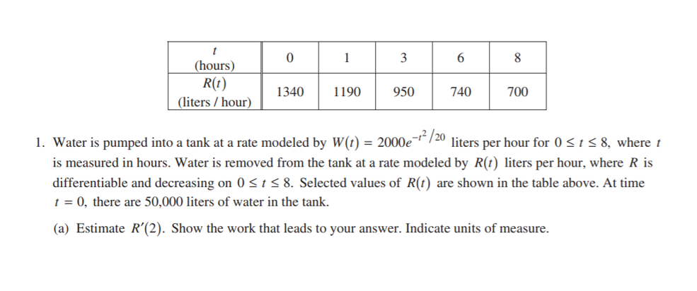

AP Theorem Practice Problems (You may use a calculator) name ______________________________

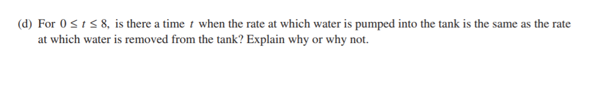

2. 

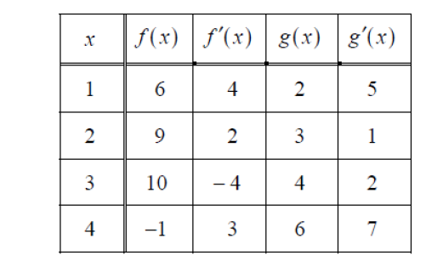



3.

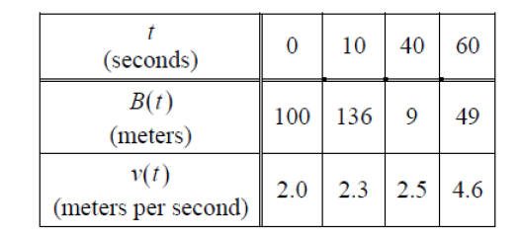

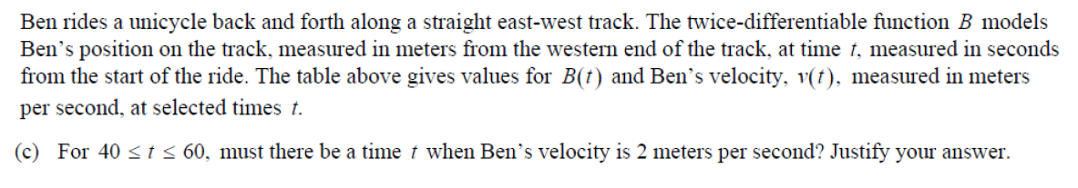

4.

